AUTONOMOUS BATTLE DAMAGE ASSESSMENT

EXPLORATORY DATA ANALYSIS
(v1.0)

DOCUMENT HISTORY

DATE | STATUS | VER | AUTHOR | NOTES
20260305 | Draft | 0.1 | Nicholas Lind | Create initial draft
20260305 | Draft | 0.2 | Nicholas Lind | Wrote paragraphs for specific sections
20260311 | Draft | 0.3 | Nicholas Lind | Inserted charts
20260312 | Draft | 0.4 | Nicholas Lind | Creating charts and tables
20260314 | Final | 1.0 | Nicholas Lind | Formatting changes

Vision Language Models for Battle Damage Assessment

Exploratory Data Analysis
16 March 2026

Students
- Benjamin Siegel
- Carlos Gil
- Cory Wingate
- Nicholas Lind
- William Benitez

Supervisors & Mentors
- Dr. Rajneesh Singh
- Dr. Priya Narayanan
- Derrik Asher
- Jason Pusey
- CPT Jesse Barkley

1.0 PURPOSE

The purpose of this Exploratory Data Analysis (EDA) is to understand the image dataset used in this project. The dataset consists of an open source collection of 100 labeled images containing military equipment, buildings, or a mix of both. Images feature objects with various levels of destruction and angles of photography. The intent is to support the training, validation, and evaluation of the VLM pipeline for Automated Battle Damage Assessment (BDA) reporting.

2.0 DATA DISTRIBUTIONS

2.1 TARGET TYPE DISTRIBUTION

The chart below shows the breakdown of image subjects in the dataset (vehicles vs buildings vs mixed).
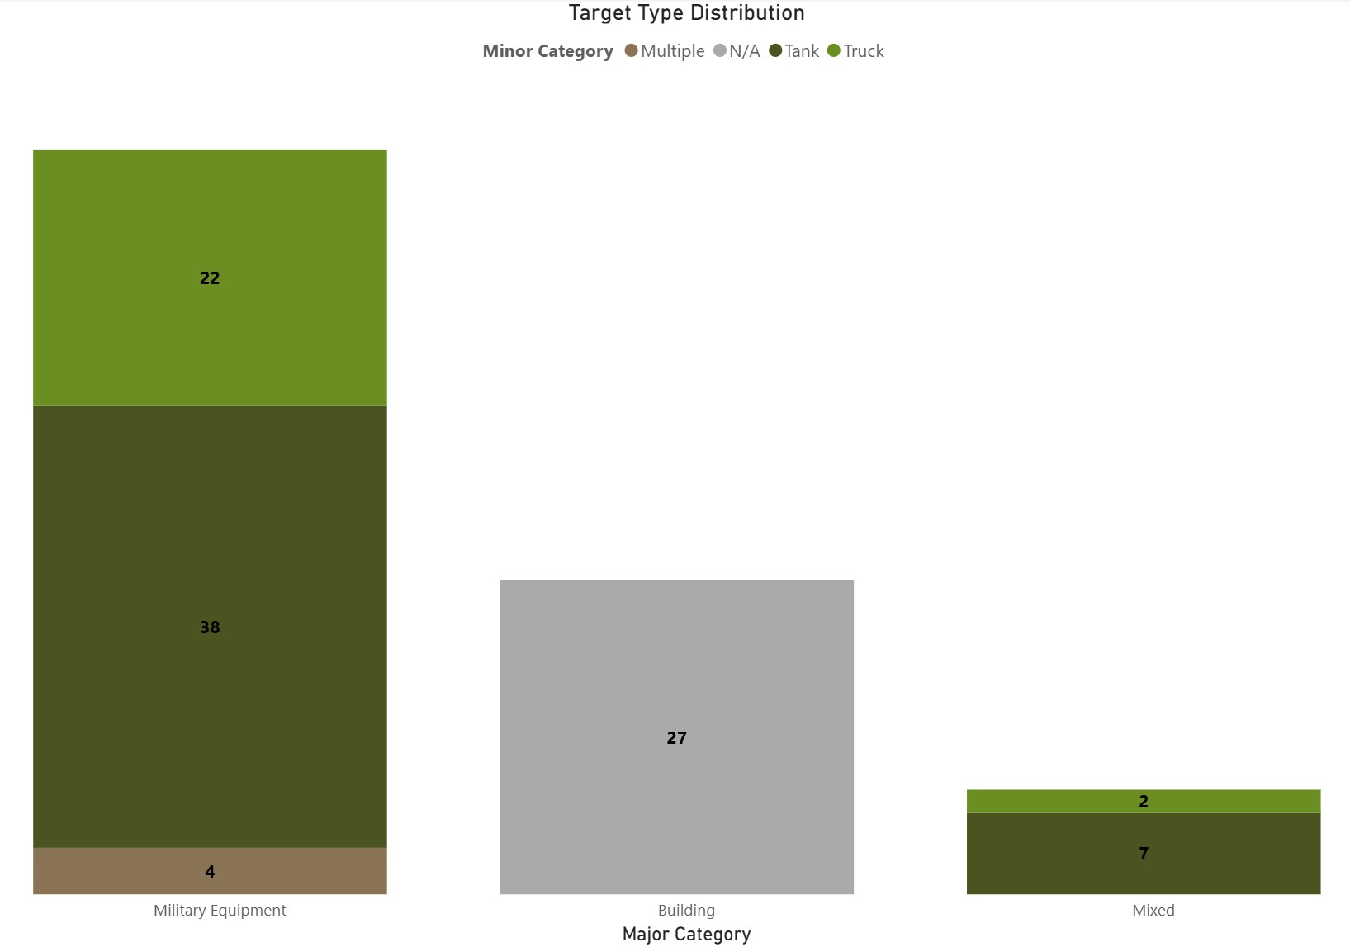

2.2 VIEW ANGLE DISTRIBUTION

The chart below displays the frequency of each image perspective (aerial, ground-level) across the dataset.
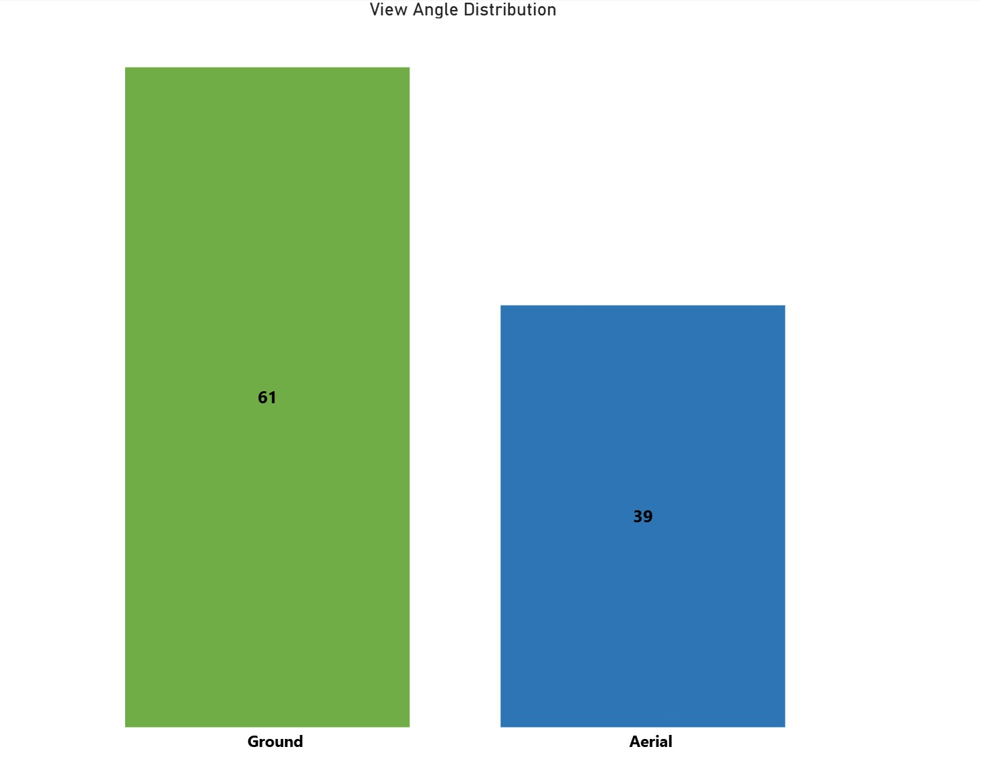
The dataset consists of 61 ground-level images and 39 aerial images. The higher proportion of ground level images is intentional, as the VLM system is going to be deployed on an autonomous ground platform for field-level battle damage assessments.

2.3 IMAGE RESOLUTION / SCALE

The bar chart below shows the distribution of image resolutions across the dataset, grouped into four different tiers. The raw dataset contained around seventy unique resolutions, highlighting high variability across the dataset. The four images in the 1-Low tier are noted as potential outliers and will be addressed further in Section 4.0.
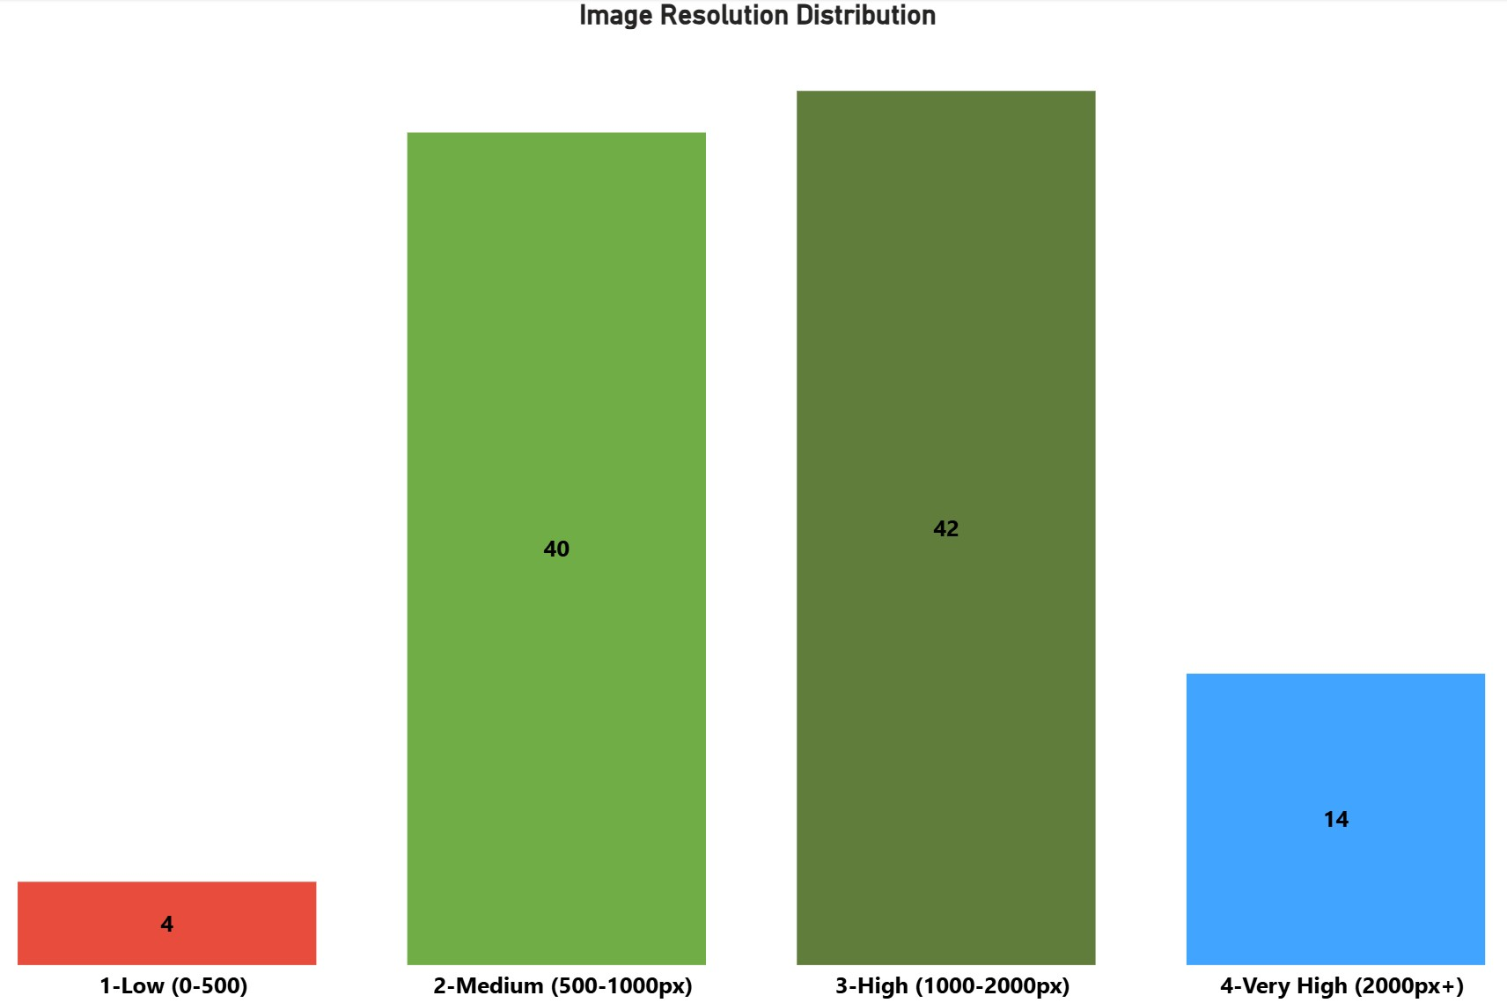

2.4 CATEGORICAL VARIABLE COUNTS SUMMARY

The table below summarizes the count and distribution of all variables across the dataset.

Category Variable | Count | Values/Labels | % of Total
Target Type | 100 | Military Equipment: 64, Building: 27, Mixed: 9 | 64% / 27% / 9%
Minor Category | 100 | Tank: 38, Truck: 22, Multiple: 4, N/A: 27, Mixed: 9 | 38% / 22% / 4% / 27% / 9%
View Angle | 100 | Ground: 61, Aerial: 39 | 61% / 39%
Damage Level | 50 | Pending - 50 of 100 images labeled | 50% complete

Military equipment is the main target type at 64%, with buildings representing 27% and mixed scenes making up the remaining 9%. Ground level images account for 61%, reflecting the intended deployment of the system on a ground based platform. Damage level classifications are currently available for 50 of the 100 images, with full labeling expected to be completed in a later project phase.

3.0 MISSING DATA

3.1 MISSING DATA IDENTIFICATION

Field / Variable | # Missing | % Missing | Action
Damage Level | 50 | 50% | In progress - being labeled in phases
Target Type | 0 | 0% | No action required
Minor Category | 0 | 0% | No action required
View Angle | 0 | 0% | No action required
Image Resolution | 0 | 0% | No action required

The only missing data identified in the dataset is the damage level classification, which is currently being completed through a manual labeling and quality review process.

3.2 SYSTEMATIC CAUSE ANALYSIS

The absence of damage level classification for 50 images is the result of an ongoing manual labeling and quality review process. Images are being systematically reviewed by each team member and labeled in phases, with the first 50 images targeted for completion in the current phase. This is an expected and planned limitation of the dataset at this stage of development, not a result of data collection errors or random errors.

3.3 HANDLING STRATEGY

The images with completed damage level labels will be used for initial VLM training and testing. The remaining 50 images will be incorporated into the dataset once the labeling and quality review process is complete. Since the images are sourced from open source collections, full context for each image is not always available. As a result, damage level classifications are based on visual estimation rather than verified ground truth. This is an acknowledged limitation of the dataset that should be considered when evaluating model output.

4.0 OUTLIERS

4.1 OUTLIER IDENTIFICATION & DECISION

Image ID | Issue | Decision
36.png | Low resolution (under 500px), insufficient detail for reliable BDA report | Include - image quality low, using for more rigorous testing
39.png | Low resolution (under 500px), insufficient detail for reliable BDA report | Include - image quality low, using for more rigorous testing
52.jpg | Low resolution (under 500px), ground level phone captured image | Include - image quality sufficient for BDA assessment
56.png | Low resolution (under 500px), ground level captured image | Include - image quality sufficient for BDA assessment

Four images were identified as low resolution. During the review of the images, two were deemed usable despite low resolution. These two outliers will remain as testing images for harder evaluation.

5.0 DESCRIPTIVE STATISTICS

5.1 NUMERIC STATISTICS

This dataset consists primarily of images and categorical labels, meaning traditional numeric descriptive statistics such as min, mean, and standard deviation are not applicable at this stage. Count distribution was already reported in Section 2.4. Performance metrics including VLM confidence scores and LLM-as-judge accuracy will be documented in a later deliverable following model evaluation.

6.0 FURTHER CONSIDERATIONS

6.1 VARIABLE RELATIONSHIPS

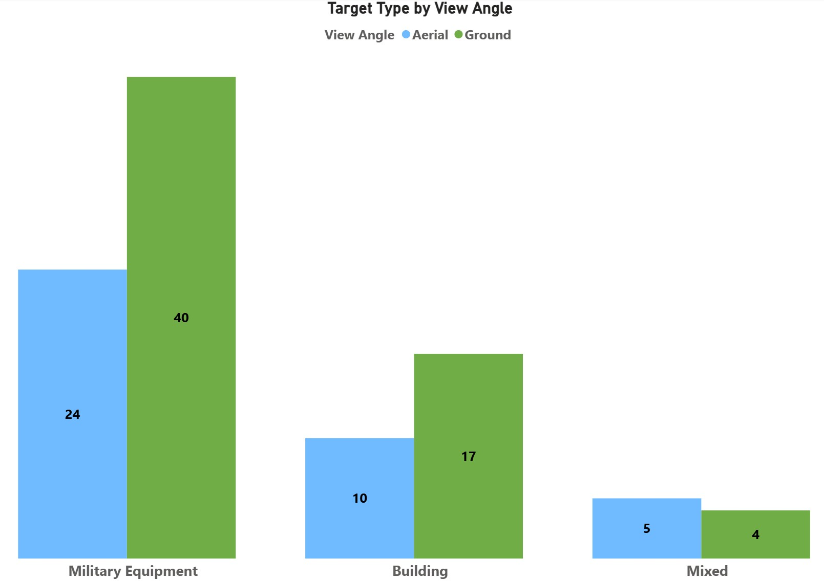
Due to the categorical nature of this dataset, variable relationships are examined using grouped barcharts rather than scatterplots. The chart below shows the relationship between target type and view angle across the dataset.

7.0 REFLECTION

While making this document I learned a lot about the dataset that has been created. There are multiple different variables at play when making a dataset from scratch. For our use case the dataset is not extremely complex. However, there still are elements that make it difficult to portray in a table or chart. The data collection process is still an ongoing effort and will be for the remainder of the project. Adding new data and creating a stronger dataset will be the best solution for our group.

8.0 APPENDIX

Glossary:
BDA (Battle Damage Assessment) - a timely and accurate estimate of damage resulting from the application of lethal and nonlethal military force.

VLM (Vision-Language Model) - An artificial intelligence model capable of processing image inputs and generating natural language outputs.

LLM-as-judge - An evaluation method where a large language model is used to compare and score outputs, in this case comparing VLM generated BDA reports against human written BDA reports to assess accuracy.

EDA(Exploratory Data Analysis) - A process of examining and summarizing a dataset using visualizations and statistics to understand its structure, distributions, and potential issues before formal analysis or modeling begins.

Damage Level - A categorical label assigned to each image describing the visible severity of destruction.

View Angle - The perspective from which an image was captured.

Tools Used:
Power BI - Used to create all data visualizations in this document including target type distribution, view angle distribution, image resolution distribution, and variable relationship charts.

Microsoft Excel - Used for dataset metadata tracking, image labeling, and categorical variable management including target type, minor category, view angle, and damage level classifications.

RoboFlow - Used for image dataset management, annotation, and preprocessing in preparation for VLM training and evaluation.

